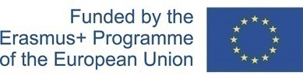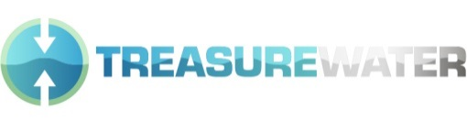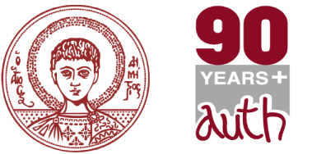

Aristotle University TREASURE WATER Meeting

"Trans-Regional Environmental Awareness for Sustainable Usage of Water Resources” 24 April – 5 may 2017
MONDAY 24 APRIL 2017
10:00-10:45 Welcome from the Director of the Division of the Hydraulics & Environmental Engineering, Dept. of Civil Engineering, AUTh Prof. N. Theodosiou
Participants’ short introduction
10:45-11:30 “Water Framework Directive + EU policies for sustainable water management” Assoc. Prof. E. Kolokytha, Dept. of Civil Engineering, AUTh
11:30-12:45 “Water Framework Directive + EU policies for sustainable water management” Assoc. Prof. E. Kolokytha, Dept. of Civil Engineering, AUTh

12:45-14:00 Lunch break

14:00-15:00 “EU WFD and GIS, databases”, Dr. H. Skoulikaris, Research Associate, Dept. of Civil Engineering, AUTh
15:00-16:00 “EU WFD and GIS, databases”, Dr. H. Skoulikaris, Research Associate, Dept. of Civil Engineering, AUTh
16:00-16:30 Discussion-Conclusions

TUESDAY 25 APRIL 2017

10:00-10:30 Dr. Galina Telegina, non EU partners TREASURE_WATER Coordinator
10:30-11:00 Prof. Edgar Wagner, Coordinator of the program, University of Freiburg
11.00-11.30 “Transboundary water management and cooperation”, Assoc. Prof. E. Kolokytha: Dept. of Civil Engineering, AUTh
11:30-12:45 “Transboundary water management and cooperation”, Assoc. Prof. E. Kolokytha, Dept. of Civil Engineering, AUTh

12:45-14:00 Lunch break

14:00-15:00 “Climate change and renewable resources of energy”, Dr. H. Skoulikaris, Research Associate, Dept. of Civil Engineering, AUTh
15:00-16:00 “Climate change and renewable resources of energy”, Dr. H. Skoulikaris, Research Associate, Dept. of Civil Engineering, AUTh
16.00- 16.30 Discussion-Conclusions

WEDNESDAY 26 APRIL 2017
9.45 Departure from the University
Axios/Vardar is one of the 5 transboundary rivers in Greece
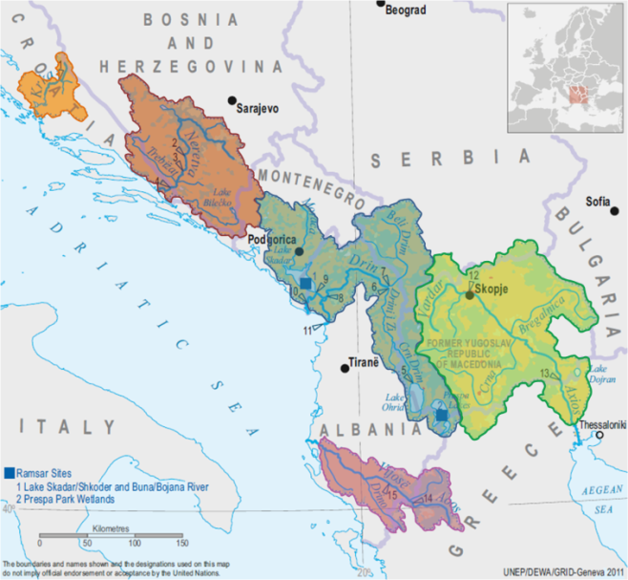
EXCURSION TO AXIOS-LOUDIAS-ALIAKMON PARK
14.00 Return to the city

THURSDAY 27 APRIL 2017
10:00-11:30 Dr. Nataliia Suchkova: Experimental investigation of phytoreclamation of sites affected by sewage sludge
11:30-12:45 Dr. Nataliia Suchkova: Utilization/reclamation of solid non-hazardous wastes as soil improvers in Greece
12:45-14:00 Lunch break

14:00-15:00 PHd candidate, D. Malamataris: “Water resources management and climate change. The Lake Koronia case, Mygdonia catchment”, Dept of Civil Engineering AUTh
15:00-16:00 “Phytoplankton Community Index – A new way of assessing ecological water quality in lakes and reservoirs”, Prof. M. Moustaka: Dept. of Biology, AUTh
16:00-16:30 Discussion-Conclusions

FRIDAY 28 APRIL 2017
9:30 Visit to the Metro station works at Venizelou / University

13:30-15:00 Lunch break
15:00-16:30 “Diachronic evolution of water supply and hydraulic works of water exploitation” -Hydrotechnologies, Assoc. Prof. K. Voudouris, Dept. of Geology AUTh
16:30-17:00 Discussion-Conclusions

MONDAY 1 MAY 2017
LABOUR DAY- DAY OFF

TUESDAY 2 MAY 2017
9.00 Departure from the University
EXCURSION TO ALIAKMONAS & WWTP SINDOS 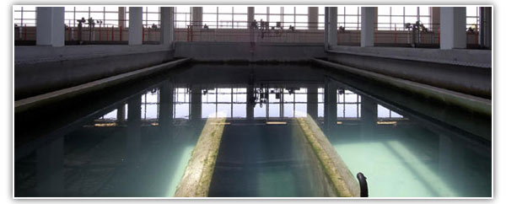
The Thessaloniki Water Treatment Facility (the Refinery) lies 2km north of the Sindos Industrial Area close to the Thessaloniki – Edessa National Road
14.00 Arrival in the city

WEDNESDAY 3 MAY 2017
9:30-10.00 Welcome of the Dean of the Civil Engineering Department AUTh, Prof. P. Prinos
10:00-11:00 Presentations of all participants /Expertise/ scientific interests / projects etc.
11.00-12.00 Presentations of all participants /Expertise/ scientific interests / projects etc.
12.00-13.00 Presentations of all participants /Expertise/ scientific interests / projects etc.

13:00-14:00 Lunch break

14:00-15:00 Presentations of all participants /Expertise/ scientific interests / projects etc.
15:00-16:00 Presentations of all participants /Expertise/ scientific interests / projects etc.
16:00-16:30 Presentations of all participants /Expertise/ scientific interests / projects etc.

THURSDAY 4 MAY 2017
10:00-11:00 Dr. G. Galitsianou: Flood Risk management, Research Associate, Dept. of Civil Engineering, AUTh
11:00-12:45 Dr. G. Galitsianou: Flood Risk management, Research Associate, Dept. of Civil Engineering, AUTh

12:45-14:00 Lunch break

14:00-15:00 “The Biological (Microalgae) Composition as an Evidence for the Sustainable Use of Waters - The Greek Example from Extreme Aquatic Environments”, Prof. em. Athena Oikonomou, National & Kapodistrian University of Athens
15:00-16:00 , “The Biological (Microalgae) Composition as an Evidence for the Sustainable Use of Waters - The Greek Example from Extreme Aquatic Environments”, Prof. em. Athena Oikonomou National & Kapodistrian University of Athens
16:00-16:30 Discussion-Conclusions

FRIDAY 5 MAY 2017
10:00-12:00 COORDINATION MEETING
12:00-13:30 Dr. Galina Telegina / Edgar Wagner, Coordination of future actions of the program
Conclusions & further planning
13.30 Lunch break
END OF THE MEETING

